**Secure Coding practices**

I created a small sub-program for checking on number type (see below)

However, revising this sub-program to check for equal to or less than zero (<=) created inconsistent results where instead the rate amount became 1.

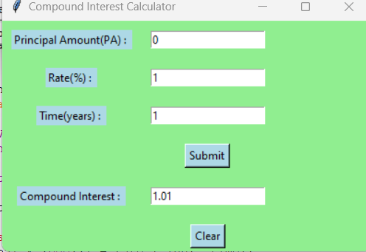

So, I found it better to leave the formulas as is even if you get a zero and negative amount (which could be considered as a loan)

**Screen Shots of program running.**

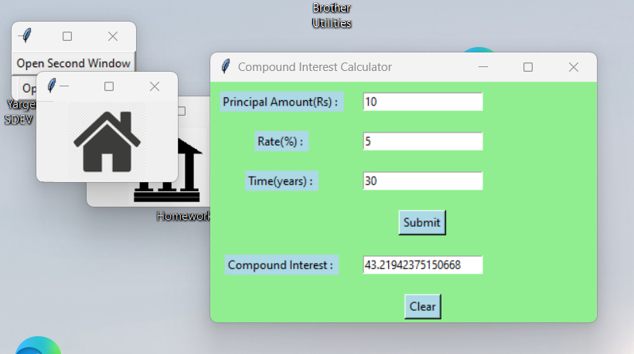

**Calculator screenshots**

**1 + 7 5*5 10/2**

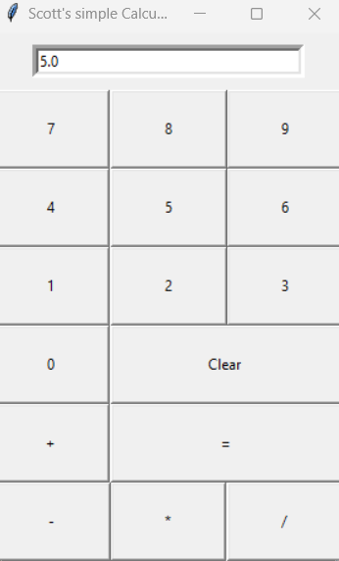

**Changes and Modifications**

My results of testing. I didn't like my initial color choices, so I changed to blue and green color scheme. I decided a float instead of integer rate would be best in this situation. Initially, I had hoped to put the graphics on the same screen as the calculator. However after a lengthy trouble-shooting process I found out that since the interest calculator used a "grid" layout and the graphics needed a "pack()" command that the two wouldn't work together and caused an error message. Also the Tk() and PhotoImage modules were being called twice which resulted in a reference error. So for this application, I created the two images on their own separate screen. I have included that module separately to verify. The two images were on my c:\png folder, however for this program I am using them with a relative location to load the images.